1

Markenson Delkhaste

Project 1

3/3/22

CIS 3050.xx

Section 07

Spring 2022

2

**Contents**

Academic honesty_ _ _ _ _ _ _ _ _ _ _ _ _ _ _ _ _ _ _ _ _ _ _ _ _ _ _ _ _ _ _ _ _ _ _ _ _ _ _ _ 3

Deliverable 1 _ _ _ _ _ _ _ _ _ _ _ _ _ _ _ _ _ _ _ _ _ _ _ _ _ _ _ _ _ _ _ _ _ _ _ _ _ _ _ _ _ _ _ 4

Deliverable 2 _ _ _ _ _ _ _ _ _ _ _ _ _ _ _ _ _ _ _ _ _ _ _ _ _ _ _ _ _ _ _ _ _ _ _ _ _ _ _ _ _ _ 5

Deliverable 3 _ _ _ _ _ _ _ _ _ _ _ _ _ _ _ _ _ _ _ _ _ _ _ _ _ _ _ _ _ _ _ _ _ _ _ _ _ _ _ _ _ _ 6

References _ _ _ _ _ _ _ _ _ _ _ _ _ _ _ _ _ _ _ _ _ _ _ _ _ _ _ _ _ _ _ _ _ _ _ _ _ _ _ _ _ _ 7

3

**Statement of Academic Honesty**

My name is: Markenson Delkhaste, I declare that, except where fully referenced no aspect of this project has been copied from any other source. I understand that any act of Academic Dishonesty such as plagiarism or collusion may result in serious offense and punishments. I promise not to lie about my academic work, to cheat, or to steal the words or ideas of others, nor will I help fellow students to violate the Code of Academic Honesty.

Name: Markenson Delkhaste Date: 3/3/22

Signature: 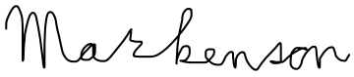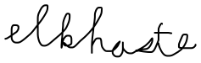

4

This project is about designing a database management system to address practical   
database needs and implements a relational database based on that design. My database   
system is designed to perform general information management tasks such as   
systematic collection, update, and retrieval of information for a small organization. For instance, it tracks employee information but it could be done using other (and possibly better) software.

5

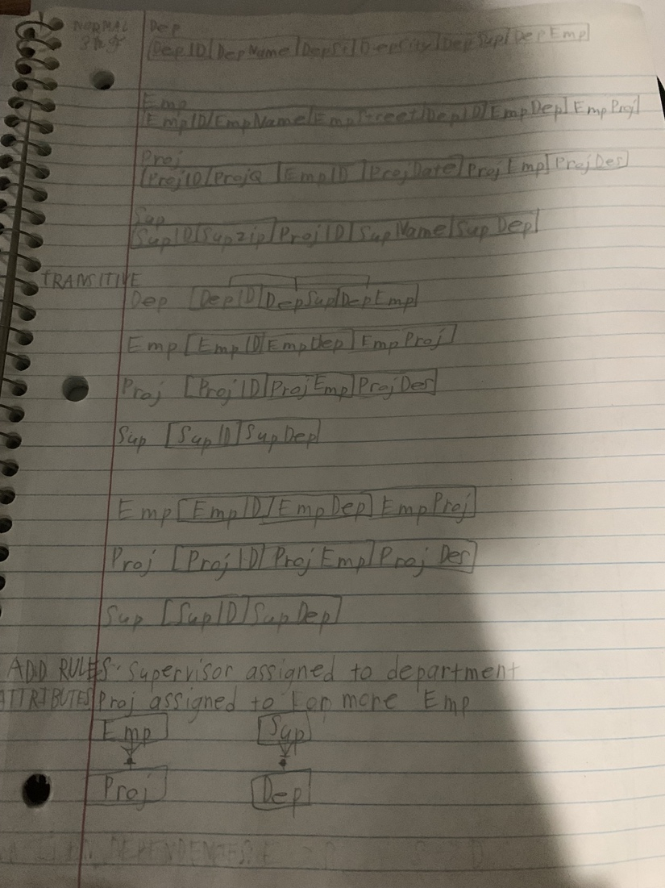

6

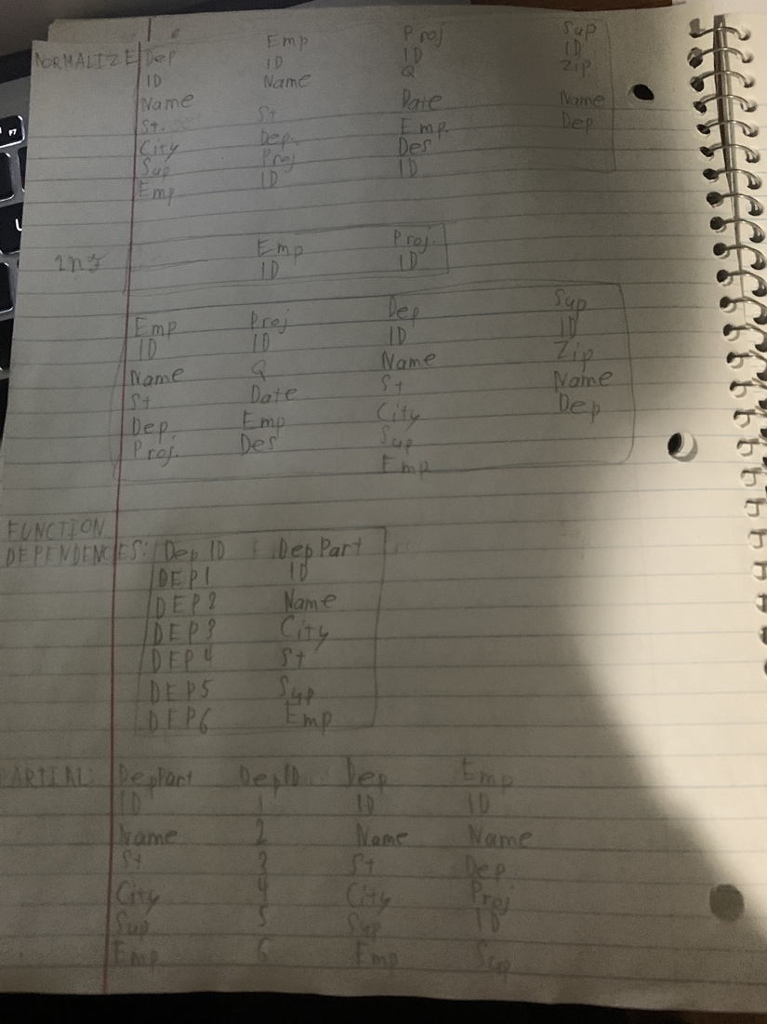

7

The project made more sense as it developed and led to more edits to make it even more optimized. Of course, in order to minimize or simplify the data, transforming the information was required. Turning the project into 3nf helped with organizing. Perhaps condensing this into one picture or database could have made it look better.

8

Learning about how to make databases was intriguing for me. It helped me apply what was learned with transitive versus full functional dependencies. In addition, it helped me learn how to apply the different normalization forms better. Applying how one form does not require which key was educational.

9

The project is making a great and optimized database management system to address a practical   
database need and implement a relational database based on that design. My database   
system is made to perform general information management tasks such as   
systematic collection, update, and retrieval of information for a small organization. It is simplified enough to be user-friendly to an extent.

7

**References**

E Loshin, D. 2006. "Monitoring Data Quality Performance Using Data Quality Metrics." Available at https://it.ojp.gov/ documents/Infonnatica_Whilepaper Monitoring^DQ Using_Melrics .pdf.

Hay, D. C. 2005. "Data Model Quality: Where Good Data Begin." Available at <http://tdan.eom/daln-model-i.iualitywhere-good-data-begins/5286>.

Loshin, D. 2009. "The Data Quality Business Case: Projecting Return on Investment." Available at http://knowledgeintegrity.com/Assels/da ta_quality .business case.pdf.